|  |  |  |
| --- | --- | --- |
| **Aluno (a)\*** | **Valor:**  **2ºSEM/21** | **Turma/ano\*** |
|  | **Nota:** |

* **SIGA AS INSTRUÇÕES:**

1. **Atividade feita em duplas ou trios**
2. **Para as questões de múltipla escolha, utilize a ferramenta para marcar a alternativa escolhida.**
3. **Valor da atividade: 30,0 pontos para entrega na primeira data prevista. Vale a data de envio do e-mail.**
4. **datas de entrega e valores:**

**a) Data de entrega: 8/11/21  (valor total: 30,0 pontos)**

**b) Data de entrega: 15/11/21  (valor total: 21,0 pontos)**

**c) Data de entrega: 20/11/21  (valor total: 15,0 pontos)**

**4.  Os arquivos devem ser enviados no formato PDF para o email: maria.eiras@ifmg.edu.br**

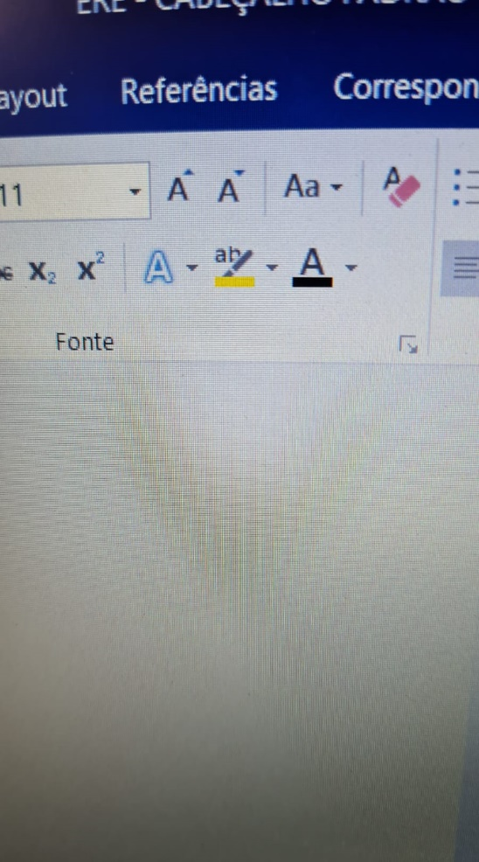

**QUESTION 1:**

**Observe os textos abaixo e com base no seu conhecimento prévio, e com a ajuda das palavras cognatas e repetidas tente identificar o tema de cada texto.**



www.bible.org/netbible/index.htm. Acesso em 01.10.08



Texto: MARQUES, A. Inglês Série Brasil. São Paulo: Ática, 2004, p. 212.

Fotos: http://images.google.com.br/images. Acesso em 01.10.08

**Q01 - Agora, sugira um título para cada um respectivamente (a sugestão do título pode ser em português).**

**Q02 - Você reconhece algum ponto de conexão entre estes dois textos? Justifique sua resposta**

**Skim the text below. Read it quickly. Don’t use a dictionary. Then, answer the question.**

**SUNDANCE BY TERESA WILSON**

I really don’t know why this book is so popular. I mean, I suppose it is going to appeal to young girls who want danger and romance, but I found this book really tedious. For a start, the characters were really unconvincing. The author went out of her way to add lots of details about the characters, but I found these details really pointless. I thought that some of the facts she presented about the main characters would become significant in some way later in the novel, but they didn’t. They were just worthless bits of information. I also was disappointed that, although this book is meant to be about kids at high school, the writer seems to have no recollection at all about what it’s like to be 17. The main character thought and acted like a 32-year old. It just wasn’t believable. I’m not saying Teresa Wilson is a bad writer. She can obviously string words together and come up with a story that is appealing to a large number of people, but she lacks anything original. There is no flair. It just uses the same sort of language as you can see in many other mediocre novels. (<https://www.eslteacher365.com/reading-strategies>. Acesso em 18/10/2021)

**Q03 - How did Kerry feel about the book?**

**Q04 - Now, scan the text again for the answers to the questions a-c. Try to use** *keywords* **in the questions to help you look for specific information.**

1. **Which *age* group will like this *book*?**
2. **Who is *Teresa Wilson*?**
3. **What does “*mediocre*” mean in the last line?**



**Q05 - What is a central idea of the text?**

1. Blue light from some LEDs can be harmful.
2. The International Dark-Sky Association (IDA) is working to restore dark night skies.
3. Excessive artificial light is causing our view of the night sky to disappear.
4. Too much artificial light disrupts animal migrations and reproduction.

**Q06 - According to paragraph 1, what is *skyglow*?**

**Q07 - How does information in Paragraph 2 support the main idea of the text?**

1. It provides historical context for the importance of dark skies.
2. It gives the history of how dark skies have slowly disappeared.
3. It answers the question of how to bring darkness back to night skies.
4. It shows how important dark skies are to the natural environment.

**Q08 - What does this sentence from paragraph 3 show the reader?**

*“Yet it was only about a century ago that nearly everyone alive could...see countless stars filling the dark night sky.”*

1. It will be easy to turn the clock back and restore dark night skies.
2. People no longer value being able to see the stars at night.
3. Dark night skies are an unrecoverable loss for humanity.
4. The change to the night skies has happened recently and rapidly.

**Q09 - What does it mean in Paragraph 4 that *“light pollution is the culprit”*?**

**Q10 - What shift, if any, does the author make between Paragraph 5 and Paragraph 6?**

1. The author transitions from describing a problem’s causes to describing its effects.
2. The author transitions from describing a problem to outlining a solution.
3. The author transitions from describing differences to describing similarities.
4. The author continues to give further evidence of the severity of a problem.

**Q11 - How does the information in paragraph 7 relate to the rest of the text?**

**Q12 - In your own words, summarize the actions that can be taken to restore dark night skies.**

**Leia o texto abaixo para responder as respectivas questões.**

**Q13 - Qual o gênero textual, a finalidade, o tema e o público alvo deste texto?**

**Q14 - Quais são as palavras cognatas deste texto que indicam uma similaridade entre nossa disciplina e o assunto abordado pelo livro ao qual este texto pertence?**

**Q15 - Na segunda parte do texto, “*The Exercises*”, qual página poderia ser sugerida a você para ampliar seus conhecimentos sobre o assunto abordado em nossa aula? Justifique sua resposta.**